REGRESSION TEST

TC002-STEP 1: Input Email

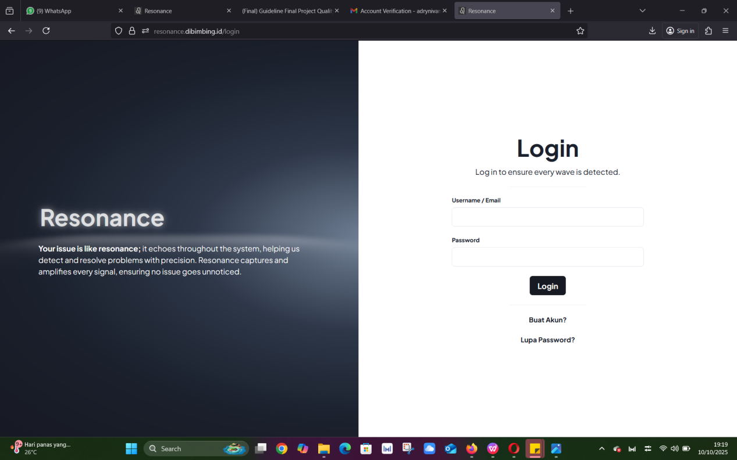

EXPECTED RESULT:

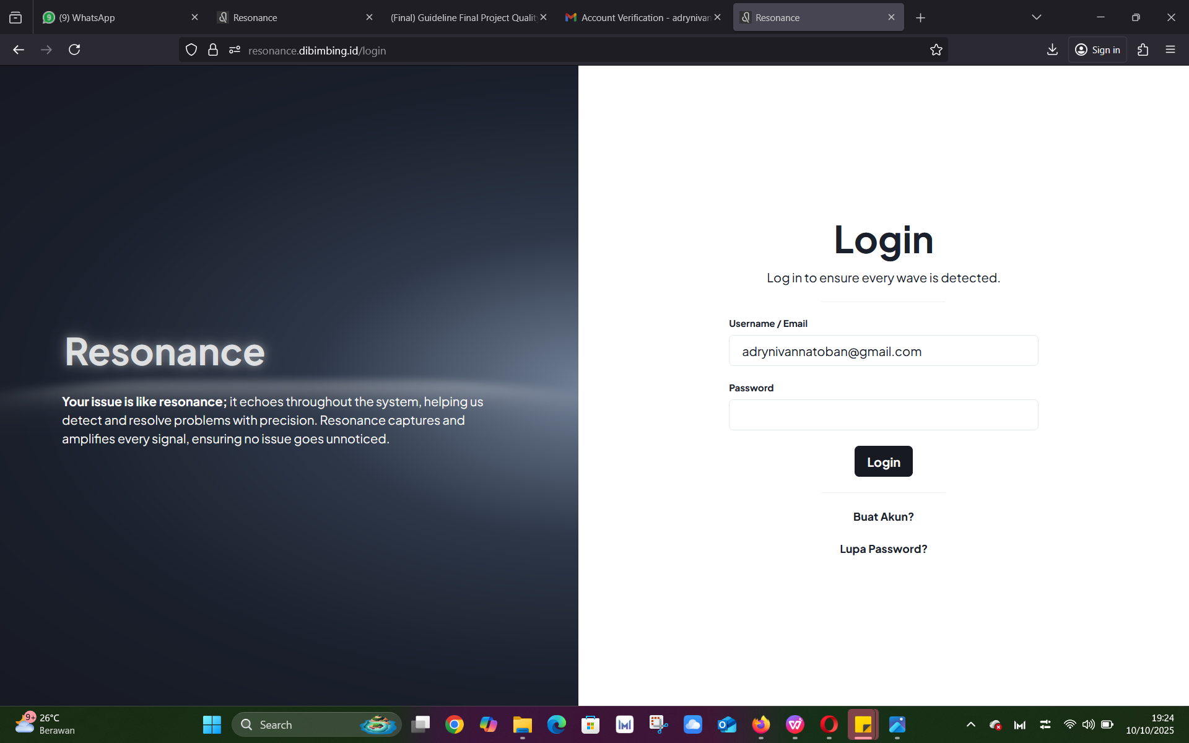

TC002-STEP 2: Input Password



EXPECTED RESULT:

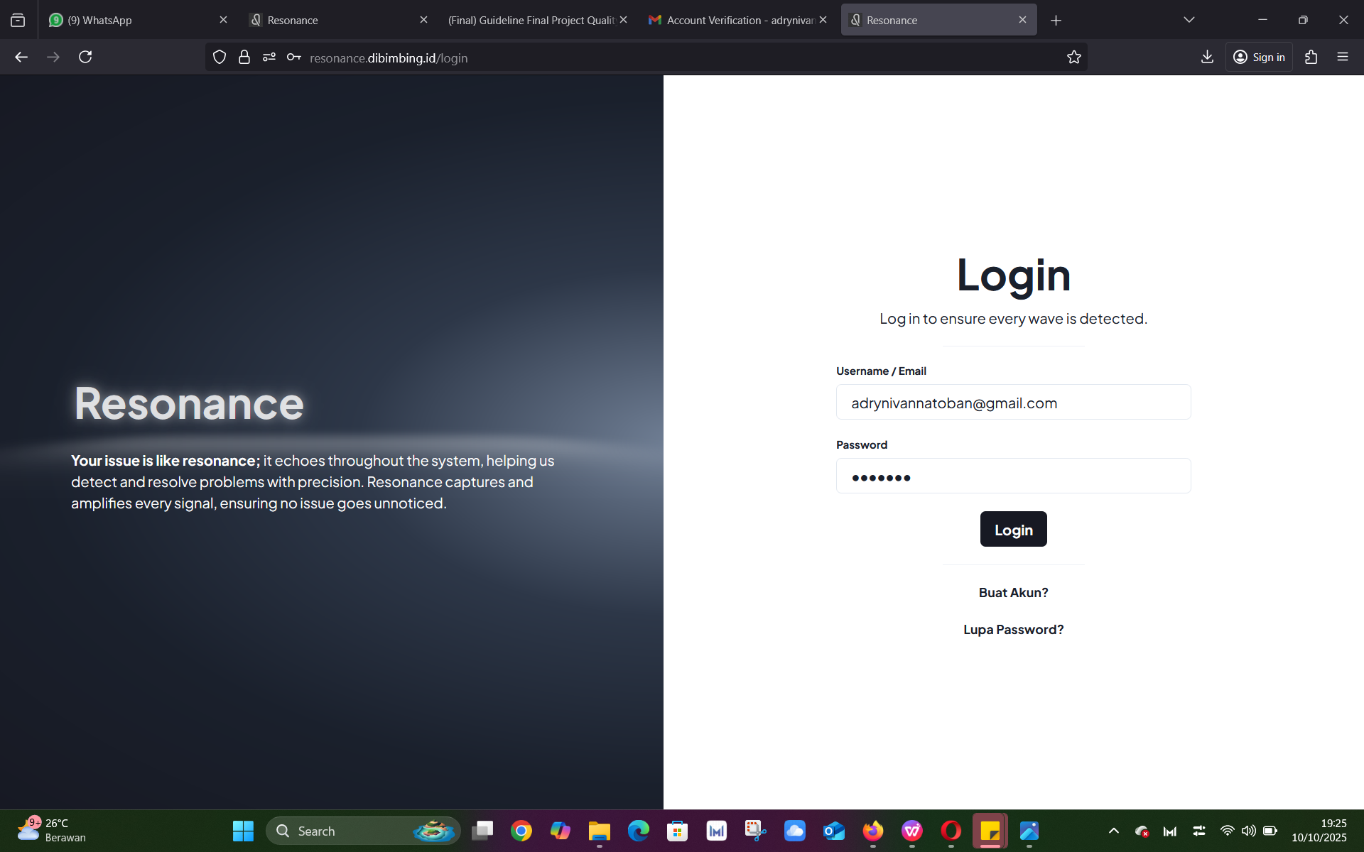

TC002-STEP 3: Klik Button Login



EXPECTED RESULT:

